Segment Containment in a Line

Definition
# Source: AI Source: Provided by: [Data Path: Persons Table -> ID Column: 1, Name_En Column: Motasem Essam] -> From: [ChatGPT] on [7/25/2026]
Segment Containment in a Line is the geometric relationship in which a line segment lies entirely within its supporting line.
If $\overset{‾}{AB}$is a line segment and $\overset{↔}{AB}$is the line determined by its endpoints, then:
$$\boxed{\overset{‾}{AB}⊂\overset{↔}{AB}}$$
This means that every point of the segment belongs to the line.
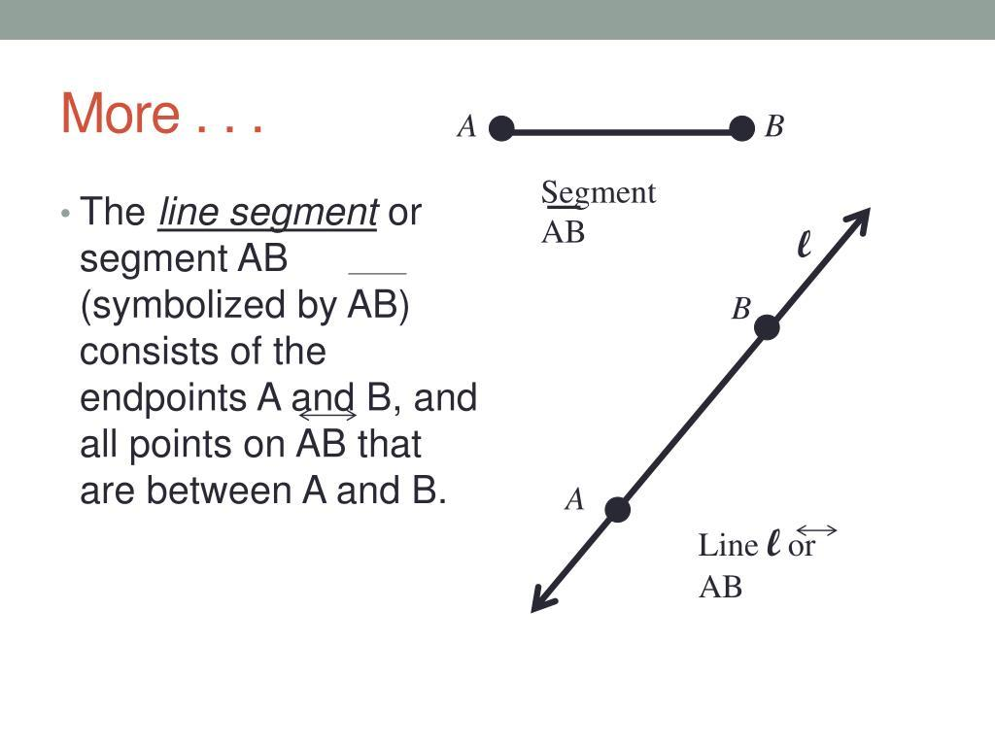
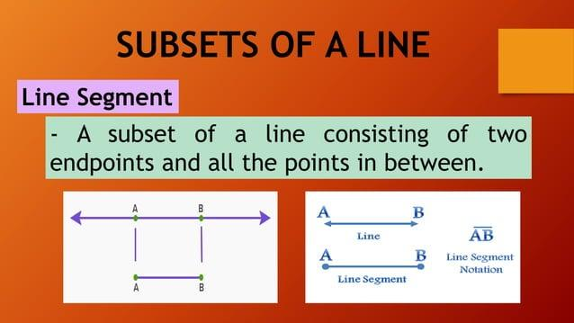
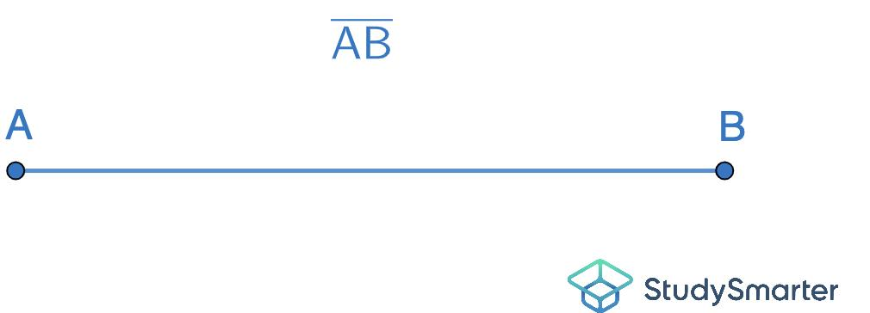

Fundamental Concept
# Source: AI Source: Provided by: [Data Path: Persons Table -> ID Column: 1, Name_En Column: Motasem Essam] -> From: [ChatGPT] on [7/25/2026]
A line segment is the finite portion of a line between two endpoints.
A line extends infinitely in both directions.
For example:
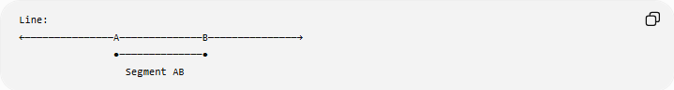
Line:
←───────────────A──────────────B───────────────→
●──────────────●
Segment AB
The segment occupies only the portion between $A$and $B$, while the line continues indefinitely in both directions.
Therefore:
$$\boxed{\overset{‾}{AB}⊂\overset{↔}{AB}}$$

Mathematical Representation
# Source: AI Source: Provided by: [Data Path: Persons Table -> ID Column: 1, Name_En Column: Motasem Essam] -> From: [ChatGPT] on [7/25/2026]
A line segment can be defined as the set of all points between $A$and $B$:
$$\overset{‾}{AB}=\left\{\left(1-t\right)A+tB∣0≤t≤1\right\}.$$
The entire supporting line is:
$$\overset{↔}{AB}=\left\{\left(1-t\right)A+tB∣t∈R\right\}.$$
Because:
$$0≤t≤1$$
is a subset of:
$$t∈R,$$
we have:
$$\boxed{\overset{‾}{AB}⊂\overset{↔}{AB}}.$$

Why the Segment Is Contained in the Line
# Source: AI Source: Provided by: [Data Path: Persons Table -> ID Column: 1, Name_En Column: Motasem Essam] -> From: [ChatGPT] on [7/25/2026]
Every point $P$on $\overset{‾}{AB}$is also a point on the supporting line.
Therefore:
$$P∈\overset{‾}{AB}$$
implies:
$$P∈\overset{↔}{AB}.$$
In set notation:
$$\boxed{P∈\overset{‾}{AB}⇒P∈\overset{↔}{AB}}$$
Consequently:
$$\boxed{\overset{‾}{AB}⊂\overset{↔}{AB}}$$

Fundamental Elements

1. Segment
# Source: AI Source: Provided by: [Data Path: Persons Table -> ID Column: 1, Name_En Column: Motasem Essam] -> From: [ChatGPT] on [7/25/2026]
The segment:
$$\overset{‾}{AB}$$
contains all points from $A$to $B$, including both endpoints.

2. Supporting Line
# Source: AI Source: Provided by: [Data Path: Persons Table -> ID Column: 1, Name_En Column: Motasem Essam] -> From: [ChatGPT] on [7/25/2026]
The line:
$$\overset{↔}{AB}$$
contains the segment and extends infinitely in both directions.

3. Endpoints
# Source: AI Source: Provided by: [Data Path: Persons Table -> ID Column: 1, Name_En Column: Motasem Essam] -> From: [ChatGPT] on [7/25/2026]
The points $A$and $B$are endpoints of the segment:
$$A,B∈\overset{‾}{AB}.$$
They are also points on the supporting line:
$$A,B∈\overset{↔}{AB}.$$

4. Interior Points
# Source: AI Source: Provided by: [Data Path: Persons Table -> ID Column: 1, Name_En Column: Motasem Essam] -> From: [ChatGPT] on [7/25/2026]
Every point between $A$and $B$is an interior point of the segment and also belongs to the line.

Coordinate Representation
# Source: AI Source: Provided by: [Data Path: Persons Table -> ID Column: 1, Name_En Column: Motasem Essam] -> From: [ChatGPT] on [7/25/2026]
Suppose:
$$A=\left(x_{1} , y_{1}\right)$$
and:
$$B=\left(x_{2} , y_{2}\right).$$
The segment can be represented parametrically as:
$$\boxed{P=\left(1-t\right)A+tB, 0≤t≤1}$$
while the supporting line is:
$$\boxed{P=\left(1-t\right)A+tB, t∈R}$$
The difference is the parameter range.
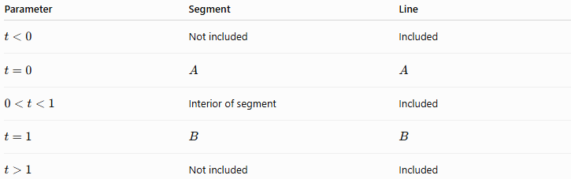
Parameter | Segment | Line
$$t<0$$ | Not included | Included
$$t=0$$ | $$A$$ | $$A$$
$$0<t<1$$ | Interior of segment | Included
$$t=1$$ | $$B$$ | $$B$$
$$t>1$$ | Not included | Included

Example
# Source: AI Source: Provided by: [Data Path: Persons Table -> ID Column: 1, Name_En Column: Motasem Essam] -> From: [ChatGPT] on [7/25/2026]
Let:
$$A=\left(1 , 2\right)$$
and:
$$B=\left(7 , 2\right).$$
The supporting line is:
$$y=2.$$
The segment is the finite portion:
$$1≤x≤7, y=2.$$
Therefore:
$$\overset{‾}{AB}=\left\{\left(x , 2\right)∣1≤x≤7\right\}.$$
And:
$$\overset{↔}{AB}=\left\{\left(x , 2\right)∣x∈R\right\}.$$
Thus:
$$\boxed{\overset{‾}{AB}⊂\overset{↔}{AB}}.$$

Example: Point Inside the Segment
# Source: AI Source: Provided by: [Data Path: Persons Table -> ID Column: 1, Name_En Column: Motasem Essam] -> From: [ChatGPT] on [7/25/2026]
Consider:
$$P=\left(4 , 2\right).$$
Because:
$$1≤4≤7,$$
we have:
$$P∈\overset{‾}{AB}.$$
Since the entire segment is contained in the line:
$$P∈\overset{↔}{AB}.$$
Therefore:
$$\boxed{P∈\overset{‾}{AB}⇒P∈\overset{↔}{AB}}$$

Example: Point on the Line but Not on the Segment
# Source: AI Source: Provided by: [Data Path: Persons Table -> ID Column: 1, Name_En Column: Motasem Essam] -> From: [ChatGPT] on [7/25/2026]
Consider:
$$Q=\left(10 , 2\right).$$
Since:
$$Q∈\overset{↔}{AB},$$
the point lies on the supporting line.
However:
$$10>7,$$
so:
$$Q∉\overset{‾}{AB}.$$
Therefore:
$$\boxed{Q∈\overset{↔}{AB} \text{but} Q∉\overset{‾}{AB}}$$
This demonstrates why containment is one-way:
$$\boxed{\overset{‾}{AB}⊂\overset{↔}{AB}}$$
but:
$$\boxed{\overset{↔}{AB}⊄\overset{‾}{AB}}$$

Segment Containment in a Line vs Point Containment in a Line
# Source: AI Source: Provided by: [Data Path: Persons Table -> ID Column: 1, Name_En Column: Motasem Essam] -> From: [ChatGPT] on [7/25/2026]
These are related but different concepts.
Point Containment
A point $P$is contained in a line $l$:
$$\boxed{P∈l}.$$
Segment Containment
A segment $\overset{‾}{AB}$is contained in a line $l$:
$$\boxed{\overset{‾}{AB}⊂l}.$$
Thus, the contained object is different:
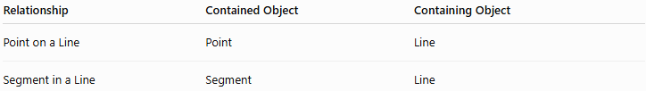
Relationship | Contained Object | Containing Object
Point on a Line | Point | Line
Segment in a Line | Segment | Line

Segment Containment in a Line vs Segment Containment in a Segment
# Source: AI Source: Provided by: [Data Path: Persons Table -> ID Column: 1, Name_En Column: Motasem Essam] -> From: [ChatGPT] on [7/25/2026]
A segment can also be contained in another segment.
For example:
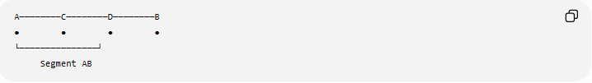
A────────C────────D────────B
● ● ● ●
└───────────────┘
Segment AB
Here:
$$\overset{‾}{CD}⊂\overset{‾}{AB}.$$
This is different from:
$$\overset{‾}{AB}⊂\overset{↔}{AB}.$$
The first is segment-in-segment containment, while the second is segment-in-line containment.

Segment Containment in a Line vs Coincidence
# Source: AI Source: Provided by: [Data Path: Persons Table -> ID Column: 1, Name_En Column: Motasem Essam] -> From: [ChatGPT] on [7/25/2026]
Containment and coincidence are not the same.
If:
$$\overset{‾}{AB}⊂\overset{↔}{AB},$$
the segment is only part of the line.
The two objects do not have the same extent.
Therefore:
$$\boxed{\overset{‾}{AB}≠\overset{↔}{AB}}.$$
They are not coincident.
Coincidence would require two objects to occupy exactly the same geometric set.

Segment Containment in a Line vs Intersection
# Source: AI Source: Provided by: [Data Path: Persons Table -> ID Column: 1, Name_En Column: Motasem Essam] -> From: [ChatGPT] on [7/25/2026]
Containment is also different from intersection.
If:
$$\overset{‾}{AB}⊂l,$$
then:
$$\overset{‾}{AB}∩l=\overset{‾}{AB}.$$
The intersection is the entire segment because every point of the segment belongs to the line.
This is a useful relationship:
$$\boxed{A⊆B⇒A∩B=A}$$
when $A$and $B$are treated as sets.

Segment Containment in a Line vs Overlap
# Source: AI Source: Provided by: [Data Path: Persons Table -> ID Column: 1, Name_En Column: Motasem Essam] -> From: [ChatGPT] on [7/25/2026]
Suppose two segments partially overlap:
A────────────D
C────────────B
Then:
$$\overset{‾}{AB}∩\overset{‾}{CD}$$
may be another segment.
This is overlap, not necessarily complete containment.
If one segment is entirely within the other:
$$\overset{‾}{CD}⊂\overset{‾}{AB},$$
then it is specifically segment containment.

Supporting Line
# Source: AI Source: Provided by: [Data Path: Persons Table -> ID Column: 1, Name_En Column: Motasem Essam] -> From: [ChatGPT] on [7/25/2026]
The term supporting line is especially useful here.
For any segment $\overset{‾}{AB}$, there is a unique line containing both endpoints $A$and $B$.
This line is called the supporting line of the segment.
Therefore:
$$\boxed{\text{Supporting Line of }\overset{‾}{AB}=\overset{↔}{AB}}$$
and:
$$\boxed{\overset{‾}{AB}⊂\overset{↔}{AB}}$$
This terminology is commonly useful in geometry, convexity, and computational geometry.

Geometric Dimension
# Source: AI Source: Provided by: [Data Path: Persons Table -> ID Column: 1, Name_En Column: Motasem Essam] -> From: [ChatGPT] on [7/25/2026]
This containment relationship connects objects of different extents but the same geometric dimension:
$$\boxed{\text{Segment (finite 1D)}⊂\text{Line (infinite 1D)}}$$
Both are one-dimensional geometric objects, but:
- a segment is finite,
- a line is infinite in both directions.

Important Properties
# Source: AI Source: Provided by: [Data Path: Persons Table -> ID Column: 1, Name_En Column: Motasem Essam] -> From: [ChatGPT] on [7/25/2026]
- Every line segment is contained in its supporting line.
- The endpoints of the segment belong to the supporting line.
- Every interior point of the segment belongs to the supporting line.
- A segment is finite.
- Its supporting line is infinite in both directions.
- The segment is a proper subset of its supporting line:
$$\overset{‾}{AB}⊊\overset{↔}{AB}.$$
- Points on the supporting line outside the segment do not belong to the segment.
- The supporting line is uniquely determined by two distinct endpoints.
- Segment containment in a line is a special case of geometric containment.
- The relationship is not coincidence because the segment and line do not have the same extent.

Relationship with Related Concepts
# Source: AI Source: Provided by: [Data Path: Persons Table -> ID Column: 1, Name_En Column: Motasem Essam] -> From: [ChatGPT] on [7/25/2026]
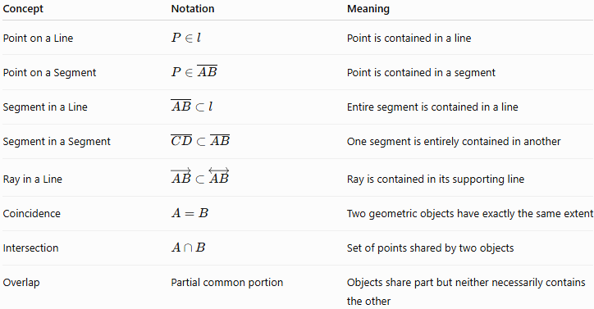
Concept | Notation | Meaning
Point on a Line | $$P∈l$$ | Point is contained in a line
Point on a Segment | $$P∈\overset{‾}{AB}$$ | Point is contained in a segment
Segment in a Line | $$\overset{‾}{AB}⊂l$$ | Entire segment is contained in a line
Segment in a Segment | $$\overset{‾}{CD}⊂\overset{‾}{AB}$$ | One segment is entirely contained in another
Ray in a Line | $$\vec{AB}⊂\overset{↔}{AB}$$ | Ray is contained in its supporting line
Coincidence | $$A=B$$ | Two geometric objects have exactly the same extent
Intersection | $$A∩B$$ | Set of points shared by two objects
Overlap | Partial common portion | Objects share part but neither necessarily contains the other

Containment Chain
# Source: AI Source: Provided by: [Data Path: Persons Table -> ID Column: 1, Name_En Column: Motasem Essam] -> From: [ChatGPT] on [7/25/2026]
There is a useful chain involving a segment, ray, and line:
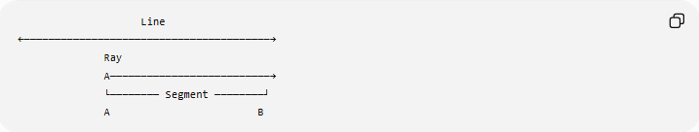
Line
←────────────────────────────────────────→
Ray
A──────────────────────────→
└──────── Segment ────────┘
A B
Mathematically:
$$\boxed{\overset{‾}{AB}⊂\vec{AB}⊂\overset{↔}{AB}}$$
Therefore:
$$\boxed{\overset{‾}{AB}⊂\overset{↔}{AB}}$$
is the specific relationship covered by Segment Containment in a Line.

Real-World Applications
# Source: AI Source: Provided by: [Data Path: Persons Table -> ID Column: 1, Name_En Column: Motasem Essam] -> From: [ChatGPT] on [7/25/2026]
Segment-in-line containment appears in:
- Engineering drawings: an edge is represented as a finite segment of an infinite geometric line.
- CAD systems: finite edges are associated with supporting lines.
- Computer graphics: line segments are treated as bounded portions of infinite lines.
- Surveying: measured baselines can be represented as finite segments on a common line.
- Coordinate geometry: finite intervals are subsets of infinite coordinate lines.
- Robotics: a finite path can lie along an infinite geometric direction.
- Computational geometry: segment-line intersection and containment tests are fundamental operations.

Key Points
# Source: AI Source: Provided by: [Data Path: Persons Table -> ID Column: 1, Name_En Column: Motasem Essam] -> From: [ChatGPT] on [7/25/2026]
- Segment Containment in a Line means an entire line segment lies within a line.
- The fundamental relationship is:
$$\boxed{\overset{‾}{AB}⊂\overset{↔}{AB}}.$$
- $\overset{‾}{AB}$is finite.
- $\overset{↔}{AB}$extends infinitely in both directions.
- The line containing a segment is called its supporting line.
- Every point of the segment belongs to the supporting line:
$$P∈\overset{‾}{AB}⇒P∈\overset{↔}{AB}.$$
- A point can be on the supporting line without being on the segment.
- In parametric form:
$$\overset{‾}{AB}:0≤t≤1$$
while:
$$\overset{↔}{AB}:t∈R.$$
- Segment containment is different from coincidence and partial overlap.
- The broader containment chain is:
$$\boxed{\overset{‾}{AB}⊂\vec{AB}⊂\overset{↔}{AB}}.$$

Conclusion
# Source: AI Source: Provided by: [Data Path: Persons Table -> ID Column: 1, Name_En Column: Motasem Essam] -> From: [ChatGPT] on [7/25/2026]
Segment Containment in a Line describes the relationship in which a finite line segment is completely contained within its infinite supporting line. Every point of the segment belongs to the line, but the line contains infinitely many additional points outside the segment. This makes the relationship a fundamental example of geometric containment and provides an important foundation for understanding supporting lines, segments, rays, intersections, overlap, coordinate geometry, and computational geometry.

